CHAPTER 1
INTRODUCTION

With the rapid growth of urban populations and vehicle usage, parking management has become a significant challenge in modern cities. Traditional parking systems often lack automation, leading to wasted time, traffic congestion, and driver frustration. To overcome these issues, smart parking solutions are increasingly being developed to enhance space utilization and user convenience. This project presents a Smart Parking System using Arduino, which automates the monitoring and management of parking slots in real-time. The system uses Infrared (IR) sensors to detect the presence of vehicles in each parking slot. The status of each slot—whether filled or vacant—is displayed on an LCD screen, allowing users to easily identify available spaces. A servo motor-controlled barrier at the entrance grants access only when a slot is available, ensuring efficient use of parking space. An Arduino Uno serves as the brain of the system, processing data from sensors and controlling outputs such as the display and gate mechanism. The system is powered by a regulated 5V 2A adapter, ensuring safe operation of all components. This smart parking prototype offers a low-cost, energy-efficient, and scalable solution suitable for small-scale applications such as college campuses, office buildings, and shopping centers.

  - Problem Statement

Urbanization and rapid population growth have led to a dramatic increase in the number of vehicles on the road. However, the development of parking infrastructure has not kept pace with this growth, resulting in one of the most common urban problems: the difficulty of finding a parking space. In metropolitan areas, a significant percentage of traffic congestion is caused by vehicles circulating in search of vacant parking slots. This not only wastes time and fuel but also contributes to environmental pollution and increased stress among drivers. Traditional parking systems are often inefficient, relying on manual ticketing, lack of real-time slot availability, and poor user experience. Users are frequently unaware of the location, availability, and pricing of nearby parking lots, leading to poor decision-making and underutilization of resources. Additionally, manual systems are prone to human errors, unauthorized parking, and revenue losses for parking operators. Inadequate parking management can also negatively affect emergency services, public transport, and overall city mobility. Therefore, there is a pressing need for a smart, automated, and scalable solution that can enhance the efficiency of parking management in real-time.
1.2 Objectives:
- To detect vehicle presence in individual parking slots, Use IR sensors to monitor and detect whether each slot is filled or empty, and continuously update this status in real time.
- To control gate/barrier access automatically, Implement servo motors to raise or lower the entry gate based on slot availability and vehicle detection at the entrance.
- To display live slot status on an LCD screen, Integrate a 16x2 LCD module to visually show the status of all parking slots (e.g., Slot 1: Fill, Slot 2: Empty), helping users identify available slots.
- To manage system power through regulated supply, Use a 5V 2A adapter and voltage regulator to safely power the Arduino and all connected components.
- To integrate Arduino Uno as the central controller, Program the Arduino Uno to coordinate sensor input, LCD output, and servo control, ensuring synchronized and responsive operations.
- To develop a cost-effective prototype for small parking facilities, Demonstrate a scalable, low-cost solution suitable for educational campuses, offices, or small shopping complexes.

CHAPTER 2

LITERATURE SURVEY

Shastri, A., and Singh, R. [1] propose a smart parking solution based on wireless sensor networks (WSN) deployed in multi-level parking lots. This system capitalizes on ZigBee protocol for sensor data communication to maintain low power consumption. Sensors placed at each parking slot detect the presence of vehicles and relay real-time status to a central coordinator. The system also supports historical data analysis to predict peak parking times and optimize management. Limitation: Their system is less suitable for outdoor parking lots where signal interference and environmental factors may affect wireless communication quality.
Wang, C. et al. [2] investigate an IoT-enabled smart parking system that incorporates vision-based sensing technologies complemented by ultrasonic sensors. The system uses cameras strategically positioned to capture parking occupancy while ultrasonic sensors provide supplementary data for confirmation. These inputs are processed via edge computing units to reduce data transmission latency. The system aims for a high detection accuracy and real-time response. Limitation: Camera-based solutions raise privacy issues and require substantial processing power and bandwidth.
Rajendran, P., and Vikram, S. [3] discuss the role of LoRaWAN-based communication in enabling large scale smart parking networks. The low power and long-range characteristics of LoRaWAN allow the deployment of numerous sensor nodes throughout a city-wide parking infrastructure. Their system demonstrates scalable deployment and energy efficiency, making it well-suited for smart city implementations. They show the importance of managing network traffic to maintain real-time responsiveness. Limitation: LoRaWAN’s low data rate limits its utility in scenarios requiring video or high-frequency sensor data.
Kumar, V., and Malik, N. [4] analyze various machine learning techniques integrated into smart parking systems for enabling dynamic parking space allocation and demand forecasting. Their review highlights regression models, decision trees, and reinforcement learning methods that learn from historical occupancy and traffic patterns to optimize allocation strategies. They emphasize the need for robust datasets and adaptive algorithms. Limitation: The dependency on large datasets and computational resources may hinder real-time deployment in resource-constrained environments.
Singh, R., and Kaur, P. [5] propose an energy-efficient smart parking system leveraging duty cycling protocols in wireless sensor networks. The study evaluates the trade-off between sensor node energy savings and detection response time, aiming to balance battery life extension with system responsiveness. Their simulation results suggest optimized scheduling can significantly prolong network lifetime. Limitation: These scheduling algorithms may reduce system responsiveness during peak parking demand.

Gupta, R., and Kumar, P. [6] examine wireless sensor network architectures for urban parking management, focusing on scalability and fault tolerance. They propose deploying clusters of sensor nodes connected through gateway devices to cloud servers. The system supports adaptive routing to maintain data integrity in case of node failures. Limitation: Energy consumption at cluster heads can become a bottleneck without efficient power management.
Lee, D., and Park, H. [7] develop an image processing-based parking occupancy detection system that uses edge detection and contour-based algorithms on footage from overhead cameras. The processed data is used to update real-time parking availability displays inside parking facilities. The system achieves high accuracy under controlled lighting but requires substantial computational resources. Limitation: Performance degrades under varying weather and lighting conditions.
Mukherjee, A., and Roy, S. [8] design a multi-protocol IoT platform combining Wi-Fi and LoRaWAN for smart parking, enabling real-time data transmission from heterogeneous sensors. The system prioritizes Wi-Fi for high-data devices like cameras while leveraging LoRaWAN for low-data occupancy sensors. Their hybrid approach balances bandwidth requirements and energy consumption. Limitation: Complexity in managing and synchronizing different protocols adds to system cost.
Tiwari, S., and Singh, M. [9] present an RFID-based smart parking system integrating IoT for automated vehicle identification, space allocation, and management. Vehicles are equipped with RFID tags scanned at entry points, enabling access control and record-keeping. Data is processed at a cloud server for monitoring. Limitation: Requires vehicles to have RFID tags installed, limiting flexibility for casual users.
Hussain, M., and Ali, S. [10] propose a smart parking monitoring system using a combination of infrared sensors and GSM modules without mobile app dependencies. Infrared sensors detect occupancy, and GSM modules send periodic status messages to a control center. This design is suitable for low-cost parking lots lacking Wi-Fi connectivity. Limitation: GSM communication introduces higher latency and cost compared to alternative protocols.

CHAPTER 3
SYSTEM ANALYSIS

3.1 Existing System
In traditional parking systems, most operations are manual or semi-automated. Users have to:
- Search for parking slots physically, which wastes time and fuel.
- Manually check slot availability, often resulting in congestion and improper space utilization.
- Rely on human operators for gate control and parking management.
3.2 Proposed System
The Proposed Smart Parking System automates parking space monitoring and access control using Arduino and embedded components:
- IR Sensors are used to detect the presence of vehicles in each slot.
- Real-time Slot Status is displayed on a 16x2 LCD, clearly showing which slots are filled or vacant.
- A Servo Motor Gate System is used to control vehicle entry, opening only when slots are available.
- An Arduino Uno is used as the central controller to handle all input and output operations.
- Efficient Power Supply (5V, 2A adapter) ensures smooth operation of all hardware components.
- Improved User Experience by guiding vehicles directly and reducing traffic within the parking area.

CHAPTER 4
SYSTEM REQUIREMENTS

4.1 HARDWARE REQUIREMENTS
- Arduino Uno (1 unit) – Microcontroller
- IR Sensors (6 units) – Vehicle detection in each slot
- 16x2 LCD Display – Shows slot status
- Servo Motor – Controls entry gate
- 5V, 2A Adapter – Power supply
- Breadboard & Jumper Wires – Circuit connections

4.2 SOFTWARE REQUIREMENTS
- Arduino IDE – Code writing and uploading
- Embedded C / Arduino C++ – Programming language
- MS Word / PowerPoint – Project documentation

CHAPTER 5
ADVANTAGES AND DISADVANTAGES

ADVANTAGES
- Time Efficiency: Drivers spend less time searching for parking spaces, reducing congestion and frustration.
- Optimized Space Utilization: Parking spaces are efficiently managed, ensuring maximum usage of available spots.
- Reduced Traffic Congestion: By guiding drivers directly to available parking spaces, the system reduces unnecessary driving and decreases traffic within parking lots.
- Environmentally Friendly: Reduced search time for parking spaces leads to lower fuel consumption and reduced emissions, contributing to a greener environment.
- Cost Savings for Operators: Parking lot operators can reduce labour costs and improve revenue collection efficiency through automated systems and payment processing.

DISADVANTAGES
- High Initial Cost: The installation of sensors, communication infrastructure, software, and other required technologies can be expensive for parking lot operators or city planners.
- Maintenance and Upkeep: Regular maintenance of sensors, hardware, software, and communication systems is needed to ensure smooth operation, which can be costly and time-consuming.
- Dependence on Technology: A smart parking system is highly reliant on technology. If there is a system failure, malfunctioning sensors, or technical glitches, it can cause inconvenience to drivers and parking lot operators.

CHAPTER 6

IMPLEMENTATION
6.1 FLOW DIAGRAM

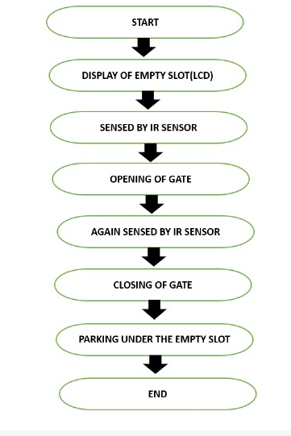

Figure 6.1: FLOW DIAGRAM

6.2 Source Code:
#include <Servo.h> //includes the servo library
#include <Wire.h>
#include <LiquidCrystal_I2C.h>
LiquidCrystal_I2C lcd(0x27, 2, 1, 0, 4, 5, 6, 7, 3, POSITIVE);
Servo myservo;
#define ir_enter 2
#define ir_back 4
#define ir_car1 5
#define ir_car2 6
#define ir_car3 7
#define ir_car4 8
#define ir_car5 9
#define ir_car6 10
int S1=0, S2=0, S3=0, S4=0, S5=0, S6=0;
int flag1=0, flag2=0;
int slot = 6;
void setup(){
Serial.begin(9600);
pinMode(ir_car1, INPUT);
pinMode(ir_car2, INPUT);
pinMode(ir_car3, INPUT);
pinMode(ir_car4, INPUT);
pinMode(ir_car5, INPUT);
pinMode(ir_car6, INPUT);
pinMode(ir_enter, INPUT);
pinMode(ir_back, INPUT);

myservo.attach(3);
myservo.write(90);
lcd.begin(20, 4);
lcd.setCursor (0,1);
lcd.print(" Car parking ");
lcd.setCursor (0,2);
lcd.print(" System ");
delay (2000);
lcd.clear();
Read_Sensor();
int total = S1+S2+S3+S4+S5+S6;
slot = slot-total;
}
void loop(){
Read_Sensor();
lcd.setCursor (0,0);
lcd.print(" Have Slot: ");
lcd.print(slot);
lcd.print(" ");
lcd.setCursor (0,1);
if(S1==1){lcd.print("S1:Fill ");}
else{lcd.print("S1:Empty");}
lcd.setCursor (10,1);
if(S2==1){lcd.print("S2:Fill ");}
else{lcd.print("S2:Empty");}
lcd.setCursor (0,2);
if(S3==1){lcd.print("S3:Fill ");}
else{lcd.print("S3:Empty");}
lcd.setCursor (10,2);
if(S4==1){lcd.print("S4:Fill ");}
else{lcd.print("S4:Empty");}
lcd.setCursor (0,3);
if(S5==1){lcd.print("S5:Fill ");}
else{lcd.print("S5:Empty");}
lcd.setCursor (10,3);
if(S6==1){lcd.print("S6:Fill ");}
else{lcd.print("S6:Empty");}
if(digitalRead (ir_enter) == 0 && flag1==0){
if(slot>0){flag1=1;
if(flag2==0){myservo.write(180); slot = slot-1;}
}else{
lcd.setCursor (0,0);
lcd.print(" Sorry Parking Full ");
delay(1500);
}
}
if(digitalRead (ir_back) == 0 && flag2==0){flag2=1;
if(flag1==0){myservo.write(180); slot = slot+1;}
}
if(flag1==1 && flag2==1){
delay (1000);
myservo.write(90);
flag1=0, flag2=0;
}
delay(1);
}
void Read_Sensor(){
S1=0, S2=0, S3=0, S4=0, S5=0, S6=0;
if(digitalRead(ir_car1) == 0){S1=1;}
if(digitalRead(ir_car2) == 0){S2=1;}
if(digitalRead(ir_car3) == 0){S3=1;}
if(digitalRead(ir_car4) == 0){S4=1;}
if(digitalRead(ir_car5) == 0){S5=1;}
if(digitalRead(ir_car6) == 0){S6=1;}
}

CHAPTER 7
RESULT

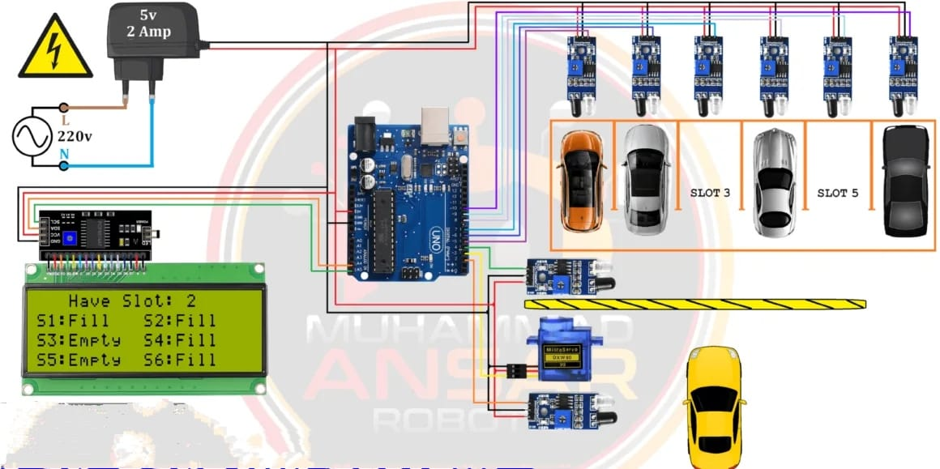

CHAPTER 8
CONCLUSION

The Smart Parking System using Arduino offers an efficient and cost-effective solution to manage parking spaces, especially in small-scale environments like colleges, offices, and shopping complexes. By using IR sensors, LCD display, and servo motors controlled through an Arduino Uno, the system provides real-time monitoring of parking slot availability and automates gate access. This project not only reduces manual effort and traffic congestion but also enhances user convenience through automation. It serves as a practical step toward smarter infrastructure and can be further expanded with IoT integration for remote access and mobile app support.

REFERENCES

www.arduino.cc – Arduino official documentation
www.electronicshub.org – IR sensor details
circuitdigest.com – LCD and servo motor interfacing
create.arduino.cc – Arduino project examples
ieeexplore.ieee.org – Smart parking system research papers
fritzing.org – Circuit design and simulation

kalaburgi

